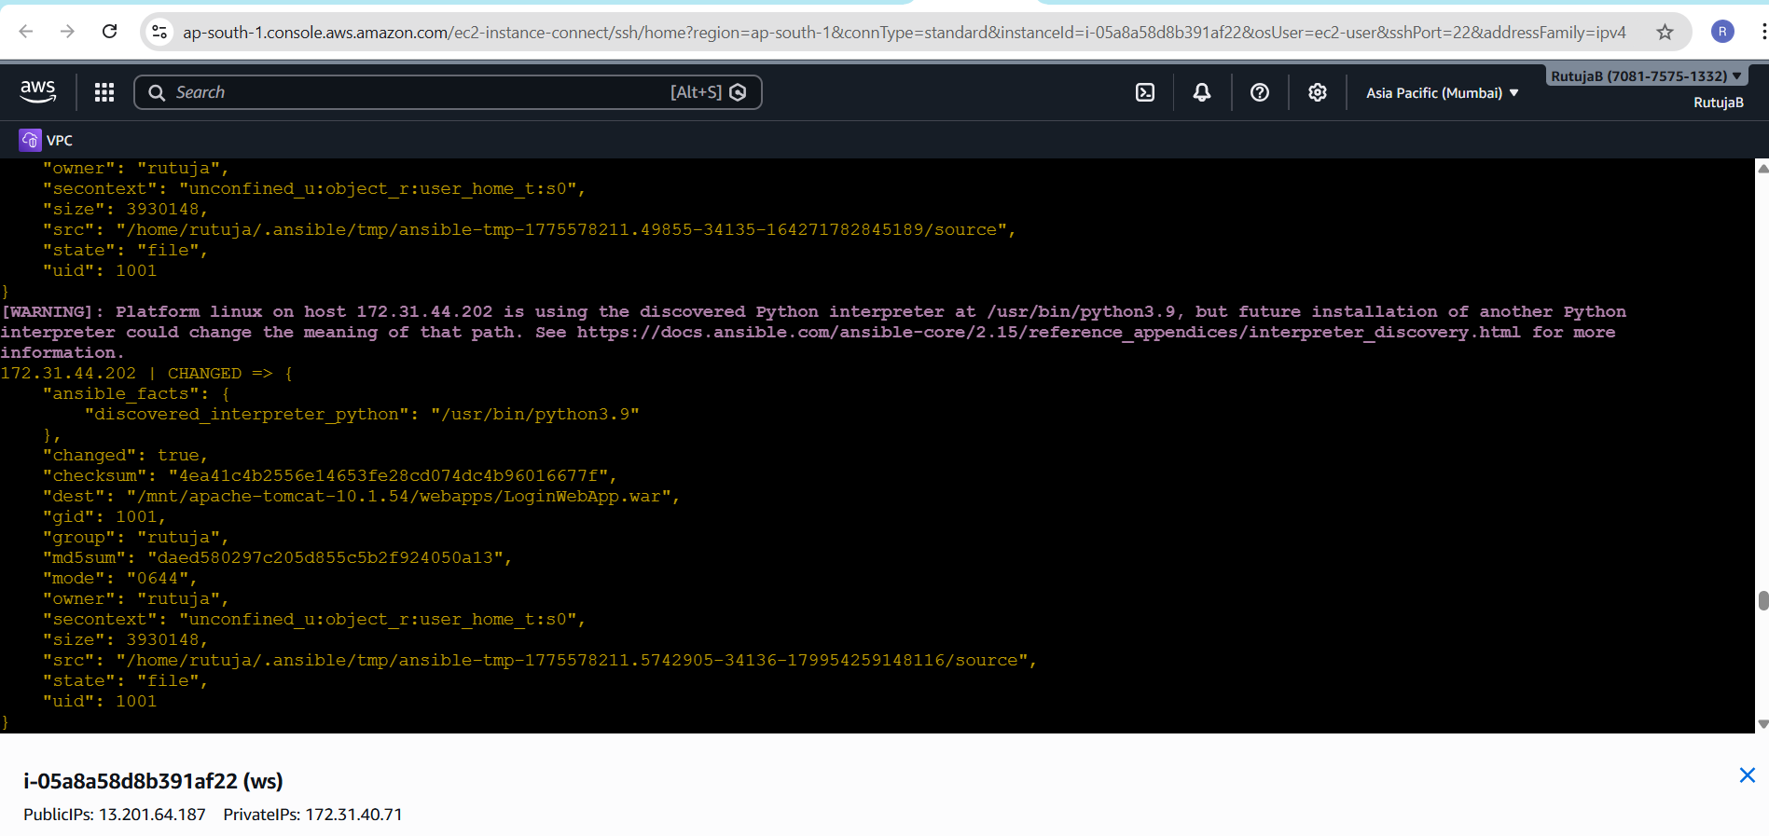
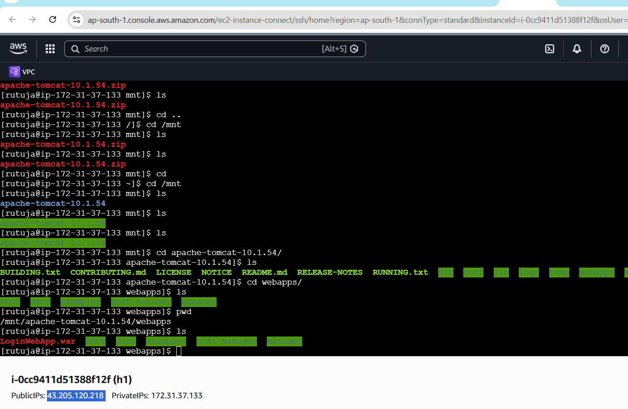
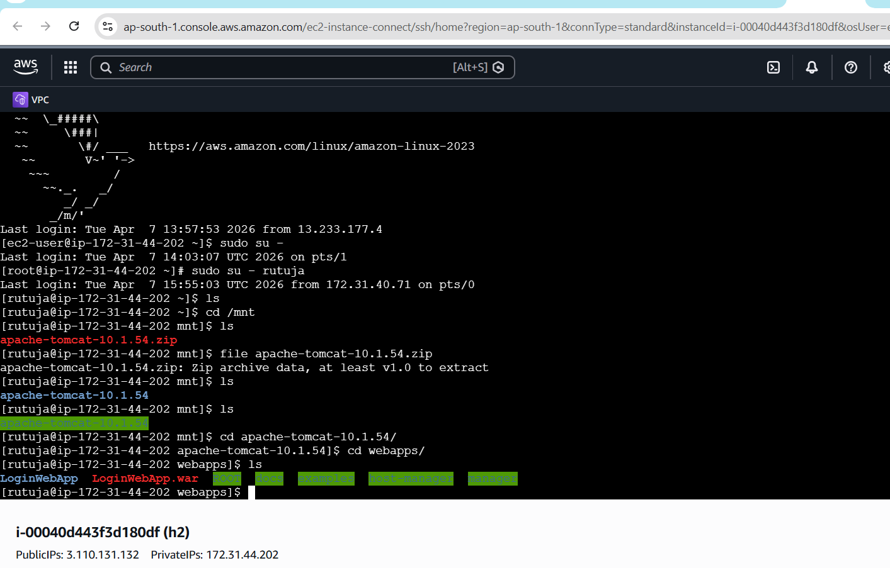
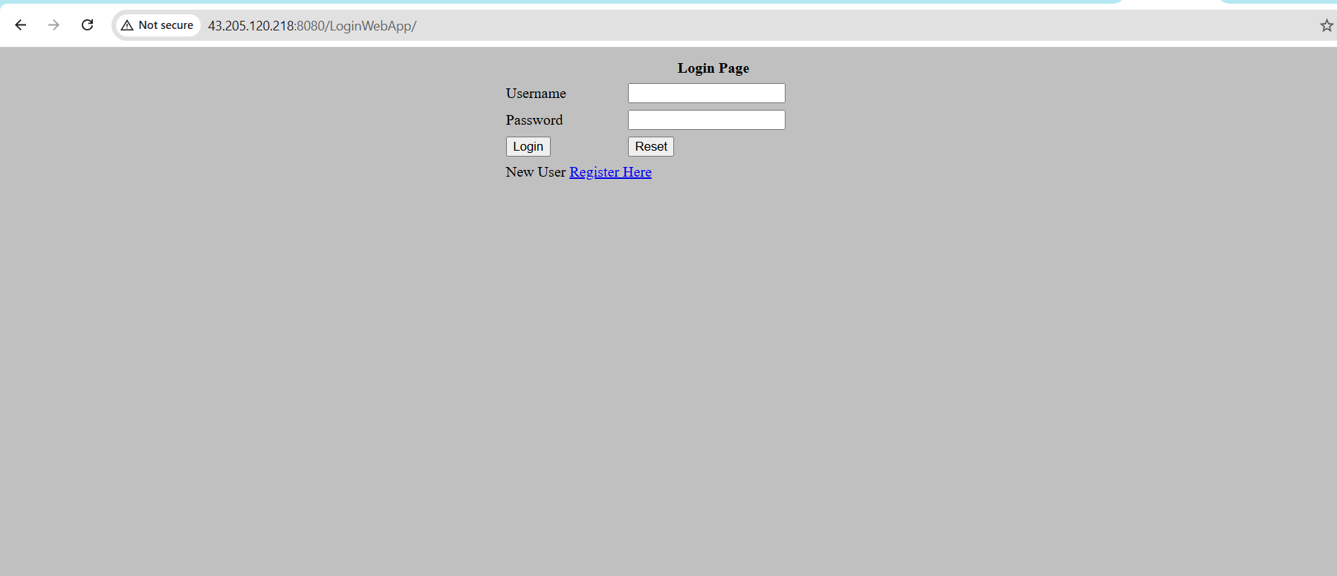
ssh-keygen-----by adhoc commands
2 ssh-key-id rutuja@172.31.37.133
3 ssh-copy-id rutuja@172.31.37.133
4 ssh rutuja@172.31.37.133
5 ssh-copy-id rutuja@172.31.44.202
6 ssh rutuja@172.31.44.202
7 sudo yum install ansible -y
8 cd /etc/ansible
9 ls
10 sudo vi ansible.cfg
11 sudo vi hosts
12 ansible devlinux -a "ls -ltr"
13 ansible devlinux -a "pwd"
14 ansible qalinux -a "ls -ltr"
15 ansible qalinux -a "pwd"
16 ansible devlinux -a "whoami"
17 ansible qalinux -a "whoami"
18 ansible devlinux -a "mkdir test"
19 ansible devlinux -a "yum install tree -y"
20 ansible devlinux -a "sudo yum install tree -y"
21 ansible qalinux -ba "yum install tree -y"
22 ansible qalinux -bm yum -a "name=git state=present"
23 ansible devlinux -bm yum -a "name=httpd" state=present"
24 ansible devlinux -bm yum -a "pkg=httpd state=present"
25 ansible devlinux -bm service -a "name=httpd state=started"
26 vi index.html
27 sudo vi index.html
28 ansible devlinux -bm copy -a "src=index.html dest= /var/www/html"
29 ansible devlinux -bm copy -a "src = index.html dest = /var/www/html"
30 ansible devlinux -bm copy -a "src=index.html dest=/var/www/html"
31 ansible all -bm get-url -a "url=https://dlcdn.apache.org/tomcat/tomcat-10/v10.1.54/bin/apache-tomcat-10.1.54.zip dest=/mnt"
32 ansible all -bm get_url -a "url=https://dlcdn.apache.org/tomcat/tomcat-10/v10.1.54/bin/apache-tomcat-10.1.54.zip dest=/mnt"
33 vi test.yaml
34 sudo vi test.yaml
35 ansible-playbook --check test.yaml
36 ansible-playbook test.yaml
37 sudo vi test.yaml
38 ansible-playbook test.yaml
39 sudo vi test2.yaml
40 ansible-playbook test2.yaml
41 sudo vi test2.yaml
42 ansible-playbook test2.yaml
43 cd
44 sudo yum list java-list*
45 sudo yum list java-17*
46 sudo yum install java-17-amazon-corretto.x86_64 -y
47 sudo yum install git -y
48 cd /mnt
49 ls
50 mkdir build-tools
51 cd build-tools
52 sudo mkdir buil-tools
53 cd build-tools
54 sudo cd build-tools
55 ls
56 cd buil-tools
57 wget https://dlcdn.apache.org/maven/maven-3/3.9.14/binaries/apache-maven-3.9.14-bin.zip
58 sudo wget https://dlcdn.apache.org/maven/maven-3/3.9.14/binaries/apache-maven-3.9.14-bin.zip
59 ls -ltr
60 sudo unzip apache-maven-3.9.14-bin.zip
61 ls -ltr
62 rm -rf apache-maven-3.9.14-bin.zip
63 sudo rm -rf apache-maven-3.9.14-bin.zip
64 ls -ltr
65 cd apache-maven-3.9.14/
66 ls
67 cd ..
68 mkdir servers
69 sudo mkdir servers
70 cd servers
71 sudo wget https://dlcdn.apache.org/tomcat/tomcat-10/v10.1.54/bin/apache-tomcat-10.1.54.zip
72 ls -ltr
73 sudo unzip apache-tomcat-10.1.54.zip
74 ls -ltr
75 sudo rm -rf apache-tomcat-10.1.54.zip
76 ls -ltr
77 sudo chmod -R 777 apache-tomcat-10.1.54/
78 ls
79 cd apache-tomcat-10.1.54/
80 ls
81 cd bin
82 ls
83 ./startup.sh
84 cd ..
85 ls
86 cd
87 ls -ltra
88 cd /mnt
89 cd buil-tools/
90 ls
91 cd'
92 cd
93 ls -ltra
94 vi .bash_profile
95 logout
96 ls
97 mvn
98 vi .bash_profile
99 mvn
100 vi .bash_profile
101 logout
102 mvn
103 cd /mnt
104 mkdir project
105 sudo mkdir project
106 cd project
107 git init
108 sudo git init
109 cd /mnt
110 ls
111 cd project/
112 ls
113 git clone https://github.com/127rutu/project.git
114 sudo git clone https://github.com/127rutu/project.git
115 ls'
116 ls
117 cd project/
118 ls
119 mvn install
120 ls
121 cd src
122 ls
123 cd main
124 ls
125 cd webapp/
126 ls
127 cd
128 cd /mnt
129 ld
130 ls
131 cd project/
132 ls
133 cd project/
134 ls
135 cd ..
136 ls
137 sudo rm -rf project/
138 ls
139 git clone https://github.com/Shantanumajan6/project.git
140 sudo https://github.com/Shantanumajan6/project.git
141 sudo git clone https://github.com/Shantanumajan6/project.git
142 ls
143 cd project/
144 mvn clean install
145 cd ..
146 ls
147 sudo rm -rf project
148 ls
149 sudo git clone https://github.com/127rutu/project.git
150 ls
151 cd project/
152 ls
153 rm -rf target
154 mvn clean package
155 mvn clean install
156 cd
157 sudo chown -R rutuja:rutuja /mnt/project/project
158 cd /mnt
159 cd project/
160 la
161 ls
162 cd project/
163 mvn clean install
164 ls
165 cd target
166 ls
167 cd
168 ansible all -bm get_url -a"https://dlcdn.apache.org/tomcat/tomcat-10/v10.1.54/bin/apache-tomcat-10.1.54.zip dest=/mnt"
169 ansible all -bm get_url -a"url=https://dlcdn.apache.org/tomcat/tomcat-10/v10.1.54/bin/apache-tomcat-10.1.54.zip dest=/mnt"
170 ansible all -bm yum -a "pkg=java17 state=present"
171 ansible all -b -m yum -a "name=java-17-openjdk state=present"
172 ansible all -bm yum -a "name=java-17-openjdk state=present"
173 ansible all -b -m yum -a "name=java-17-amazon-corretto state=present"
174 ansible all -b -m unarchive -a "src=/mnt/apache-tomcat-10.1.54.zip
175 ansible all -b -m unarchive -a "src=/mnt/apache-tomcat-10.1.54.zip"
176 ansible all -b -m unarchive -a "src=/mnt/apache-tomcat-10.1.54.zip dest=/mnt"
177 ansible all -b -m unarchive -a "src=/mnt/apache-tomcat-10.1.54.zip dest=/opt/ remote_src=yes"
178 ansible all -b -m yum -a "name=unzip state=present"
179 ansible all -b -m unarchive -a "src=/mnt/apache-tomcat-10.1.54.zip dest=/opt/ remote_src=yes"
180 ansible all -b -m shell -a "unzip -o /mnt/apache-tomcat-10.1.54.zip -d /mnt/ && rm -f /mnt/apache-tomcat-10.1.54.zip"
181 ansible all -b -m file -a "path=/mnt/apache-tomcat-10.1.54 state=directory mode=0777 recurse=yes"
182 ansible all -b -m shell -a "cd /mnt/apache-tomcat-10.1.54/bin && ./startup.sh"
183 cd /mnt
184 ls
185 cd project/
186 ls
187 cd project/
188 ls
189 cd target/
190 ls
191 pwd
192 cd
193 ansible all -b -m copy -a "src=/mnt/project/project/target/LoginWebApp.war dest=/mnt/apache-tomcat-10.1.54/webapps/LoginWebApp.war owner=rutuja group=rutuja mode=0644"
194 history

